Formatting guidelines for manuscripts:
Do not use capital letters in headlines

Name and Surname of authors and co-authors [do not include academic titles]
Department, Company/Organization [first mention your department, then the name of your organization]
City, Country, email address [don’t show ZIP codes and street address]

Abstract
The format of this text constitutes the template to be used when preparing your paper, which we kindly ask you to submit by 31 August. Your paper should not exceed 10 pages. Papers that are received after 31 August will not be published in the conference proceedings.
Your PowerPoint presentation should comprise not more than 20 slides and is due by 30 September.

Template for preparing your manuscript (do not use capital letters in headlines)
This document serves both as a guideline and a template for preparing your manuscript. It was drafted in Microsoft Word. Please use this format for your paper and submit your document in a Microsoft Word file. The conference proceedings will be published in A4 format (210 mm x 297 mm).

Formatting

Page one
Page one of your paper should state the title, as well as information about the author (see above) and an abstract presenting key facts.
Title: bold, 14 point font size and centred. Information about the author: 11 point font size, maximum 4 lines, of which line 1 indicates the name and surname, and lines 2 and 3 state the author’s department, organisation, city, country and email address.
Your abstract must not exceed 200 words in length (font size: 10 pts.). Then, indicate 6 keywords followed by your main text.
Pages should not be numbered and should not include logos.

Font and format

Text and titles
Please use Arial 10 points, normal (‘upright’) font type and line spacing set to ‘single line’. Pages should not be numbered. Titles should be numbered: bold type and 12 point font size for line one, bold type and 11 point font size for line two, and 10 point font size and no bold for line three. Do not use capital letters in titles.

Descriptions of charts, pictures and tables
Text describing charts, images and tables should be drafted in italics and 10 point font size (see below). Please number all charts, pictures and tables.

Description of pictures and tables

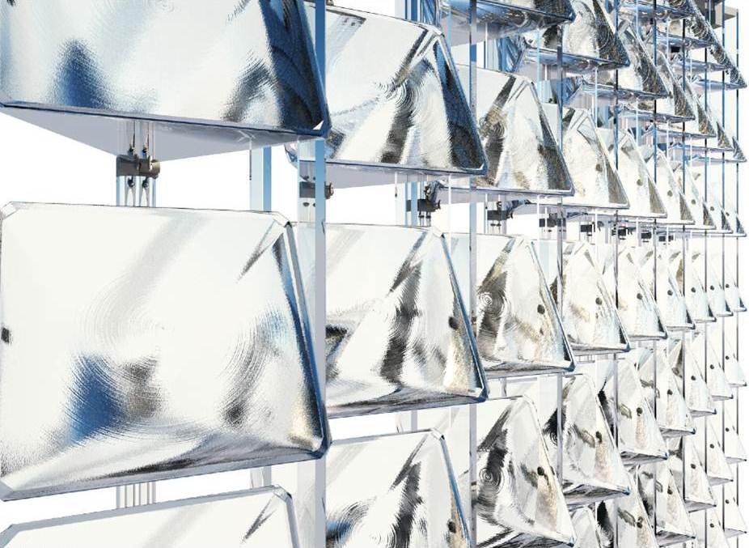

Figure 1: Text in Italics using Arial font; font size: 10 pts

Example | Value 1 | Value 2 …
1 | 1.3 | 26.5
2 | 2.6 | 48.3
3 | 1.7 | 36.5

Table 1: Tables must have a title and borders.

References
Footnotes must be numbered and grouped together at the end of the text with the footnote number in square brackets.
- E. Anderheggen, Z. Despot, P. Steffen and S.R.M Tabatabai., “Reinforced Concrete Dimensioning based on Element Nodal Forces”, ASCE Journal of Structural Engineering, Vol. 120, No. 6, 1994, pp. 1718-1731.

---------------------------------------------------------------------------------------------------------------------------------

Copyright
By submitting the paper and PowerPoint presentation, the author understands that he/she is granting the Advanced Building Skins GmbH (‘Copyright Holder’) the copyright for said publication. The Copyright Holder shall have the right to publish this work in conference proceedings or articles for advertising purposes. The author warrants that the paper and PowerPoint presentation do not infringe the intellectual property rights of any third party.
Please do not include these copyrights (i.e. the text above) in your final paper.

